**Alekhya Krishna Balivada Pyspark Assessment 3 (23-12-2023)**

**Basic Functions of Pyspark**

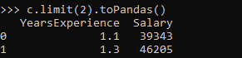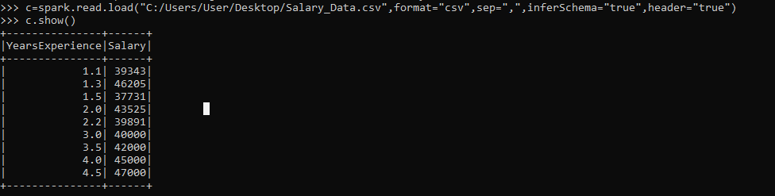**Read: Topandas:**

**Select by column: Sort:**

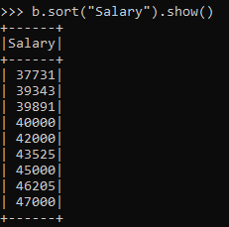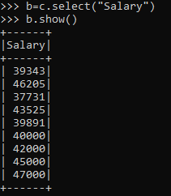

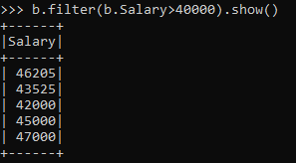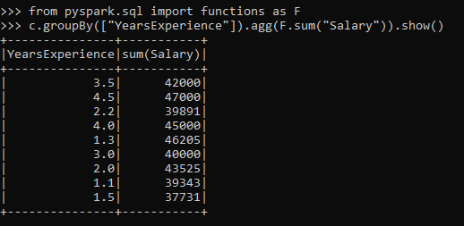**Filter: Groupby:**

**Basic spark commands**

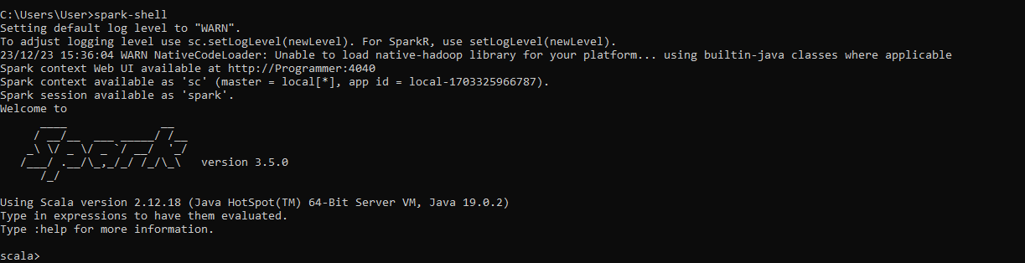**To start spark shell: Read:**

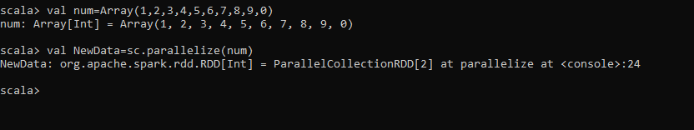**Creating RDD: Count:**

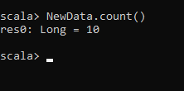

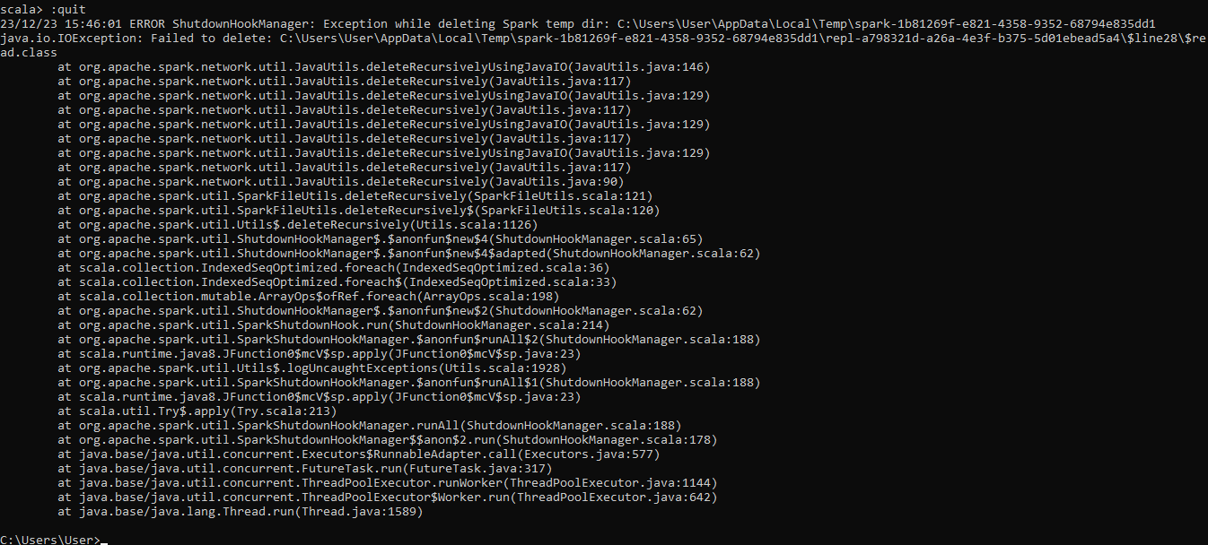**Quit:**